1.Display the details from customers table who is from country Germany.

SElECT * From dbo.customer WHERE country='Germany';

C:\Users\Shital\Pictures\Screenshots\Screenshot (349).png

2.Display the fullname of the employee.

SELECT Fistname + Lastname As Fullname, faxNumber from Employee1

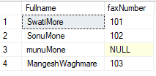

3.Display the customer details who has Fax number.

Select * from Employee1 Where FaxNumber is not null;

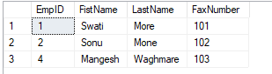

4.Display the customer details whose name holds second letter as u.

select * from Employee1 where FistName LIKE ('_u%');

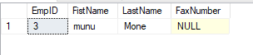

5. Select order details which contains shipping date and arrange the order by date

CREATE TABLE Order_detail

(

customerID int,

Customername varchar(20),

unit_price int,

)

select * from Order_detail;

insert into Order_detail (CustomerID,Customername,unit_price)

values(1,'mukesh',11);

insert into Order_detail (CustomerID,Customername,unit_price)

values(2,'mayur',15);

insert into Order_detail (CustomerID,Customername,unit_price)

values(3,'akash',18);

insert into Order_detail (CustomerID,Customername,unit_price)

values(4,'rahul',20);

insert into Order_detail (CustomerID,Customername,unit_price)

values(5,'sagar',22);

select * from Order_detail where unit_price>=10 and unit_price<=20;

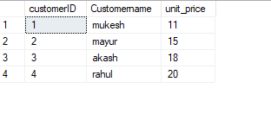

6.Display the order details which contains shipping date and arrange the order by date

select * from Orders2 ORDER BY DO_Order;

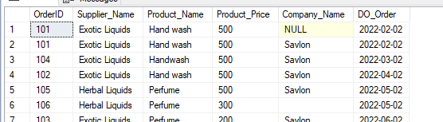

7.print the shipped by ship name’La come d’abondance’ between 2 dates.

select * from [Order] where Shipping_Name='La corne d abondance' and Shipping_date BETWEEN '2022-07-18' AND '2022-10-28'

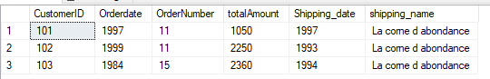

8.Print the products supplied by ‘Exotic Liquids’.

Select * from Orders2 where Supplier_Name='Exotic Liquids';

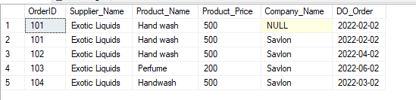

9. Print the average quantity ordered for every product.

select avg(product_Price) from Orders2;

C:\Users\Shital\Pictures\Screenshots\Screenshot (365).png

10. Print the all shipping company name and ship names if they are operational.

select * from Orders2 where Supplier_Name is not null and Company_Name='Savlon';

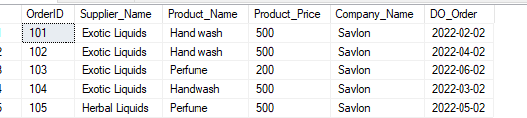

11. Print the bill for a given order id.bill should contain product.name, category name, price after discount.

select Orderitem.[OrderId],Product.[ProductName],Product.Category,[Order].[Discount-Price] From Orderitem

inner join[Order]on [Order].[order-id]=orderitem.[OrderId]inner join Product on Product.[prduct-id]=Orderitem.[Product Id]

where Orderitem.[OrderId]=401